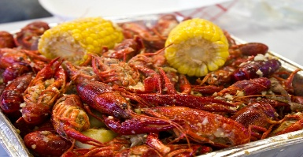
This Photo by Unknown Author is licensed under CC BY-ND
Lee Road Recreation
Crawfish Cook-Off Entry Form
Event Name:___________________________________________
Event Date:___________________Location:___________________
Team Information
- Team Name:___________________________________________
- Team Captain:_________________________________________
- Phone:___________________Email:___________________
- Mailing Address:______________________________________
Team Members(max _5__ people):
- ________________________________________________
- ________________________________________________
- ________________________________________________
- ________________________________________________
- ________________________________________________

Entry Fee
- Amount:$400______ (non-refundable)
- Payment Method:☐ Cash ☐ Check ☐ Card ☐ Online
Provided by Event:
- Minimum of _3-4__ sacks of crawfish
- Serving trays
- Event space allocation
Teams Must Provide:
- Cooking equipment (pots, burners, propane)
- Seasonings, groceries, and utensils
- Tent and tables for serving
Liability Waiver
By signing below, I acknowledge participation is voluntary, the entry fee is non-refundable, and I agree to follow all event rules. I release the event organizers from any liability for injury, loss, or damage.
Signature:___________________________Date:___________
For Office Use Only
- Entry Received: ☐ Yes ☐ No
- Payment Received: ☐ Yes ☐ No
- Team Number: __________

